Carter Wrobel and Javier Quintana

cjw446 and jaw33

CS 126 Section 1

November 13 2017

CS 126 Lab 9

1. Problem Statement

The requirements for this lab were for us to take the text file of all of the star information

and to break apart it and set the data into dictionaries to access later and print the star's position and magnitude into a turtle window.

Requirements:

* Break apart the text file into separate dictionaries
* Include the plot plain stars output and plot by magnitude output
* Set a max star size of 8 x 8 pixels

1. Planning

When we first started working on this lab our plan was to first make a new text file that only had 10 stars not the 3,000+ lines of code with all of the other stars to make sure it worked properly. Once we created that text file we started to break apart the text into the different dictionaries to access later. We split them up into the coordinates, magnitude and star name. Once we broke the text file up into the separate dictionaries, we started by printing out the coordinates to test that we were accessing the right information. Once we checked that it was looping through the right parts of the dictionaries then we plotted the points on the turtle. Once we tested that we plotted all of the main text file to make sure it worked out smoothly. When we checked that the plot plain points function worked we used that to create the plot by magnitude function and with that we just had to access the magnitudes of the text file correlating with the star and that is how big the star would be.

1. Implementation and Testing

One of the things that really helped in creating the program as a whole was the set of functions that we had to make before making a complete product. It helped us set steps that we could do to make sure that we had our correct order to open the file and then try and plot the stars correctly. Making each function was done running a loop based on the x and y coordinates. After that we moved on to make the magnitude function and making the size of the stars proportionate to its magnitude.

Plot plain stars output

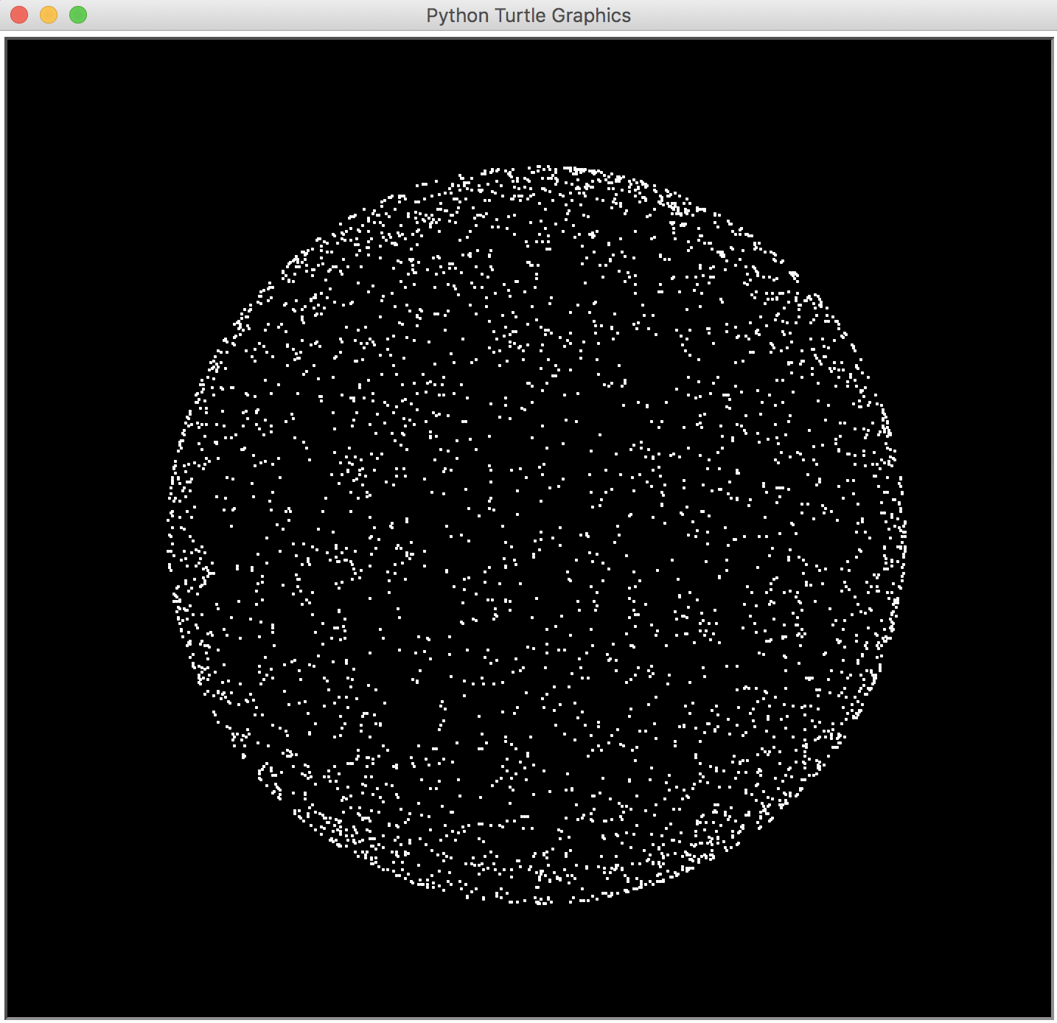

Plot by magnitude output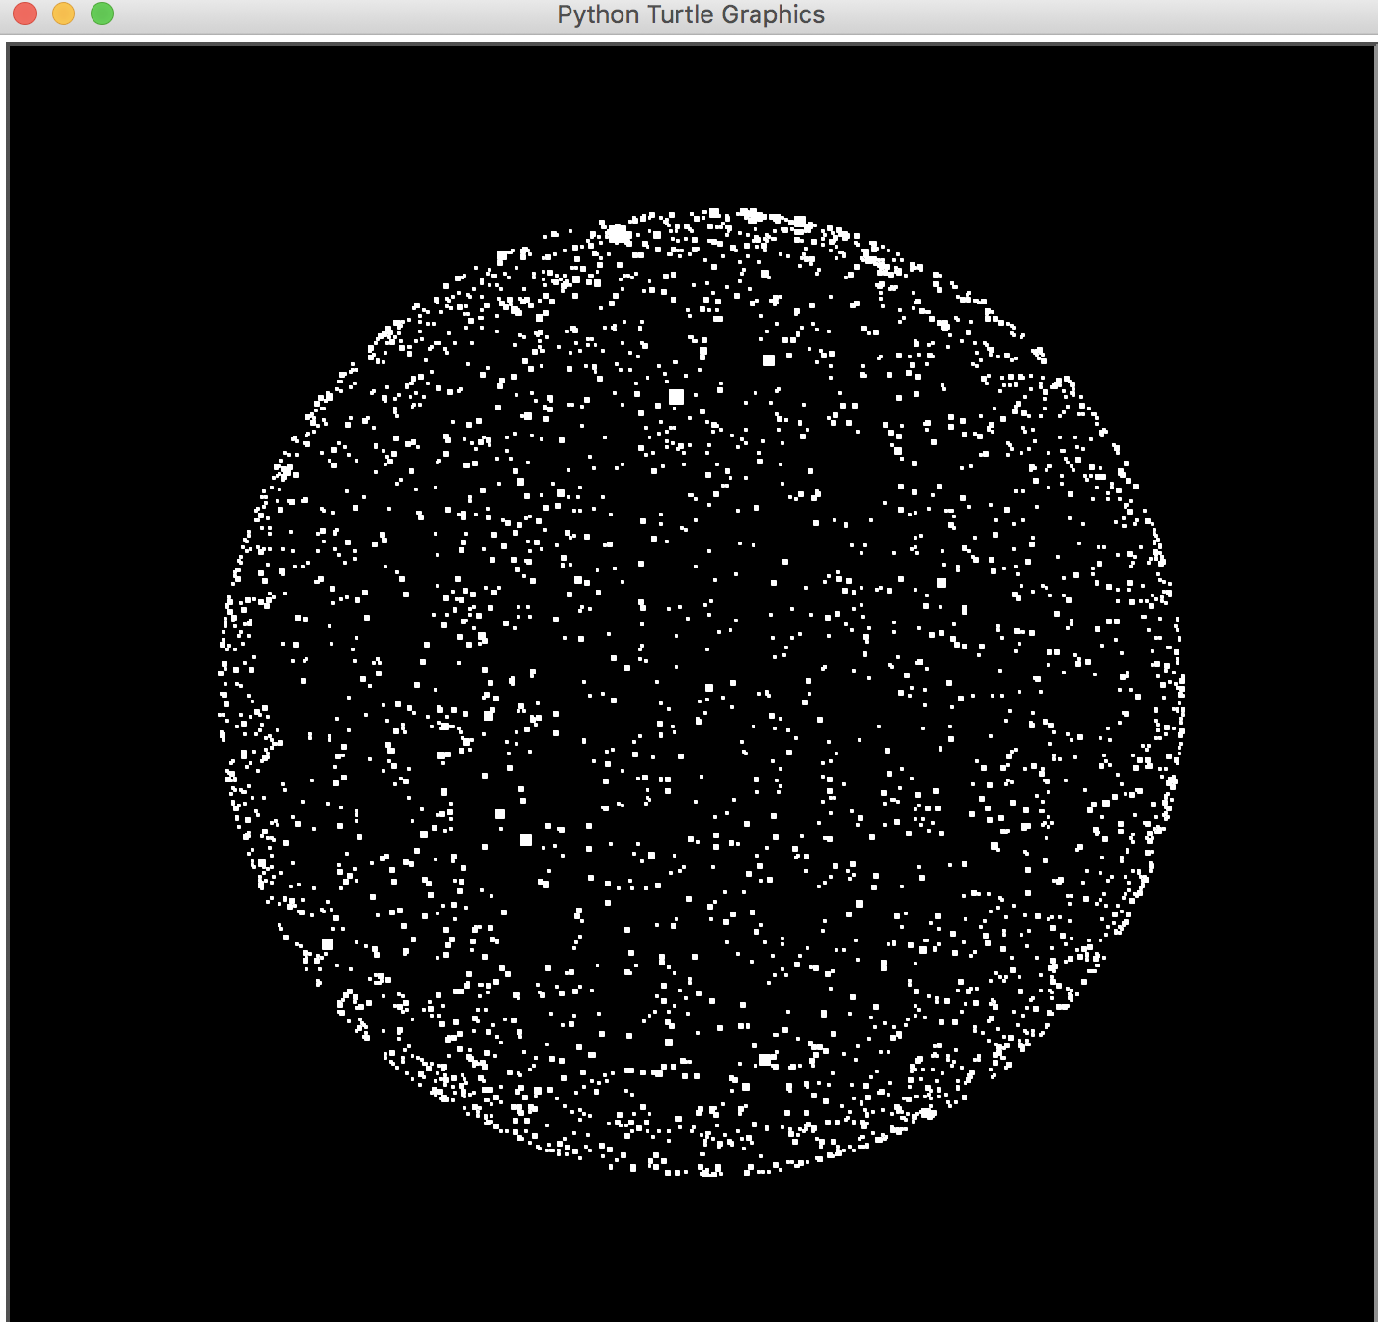

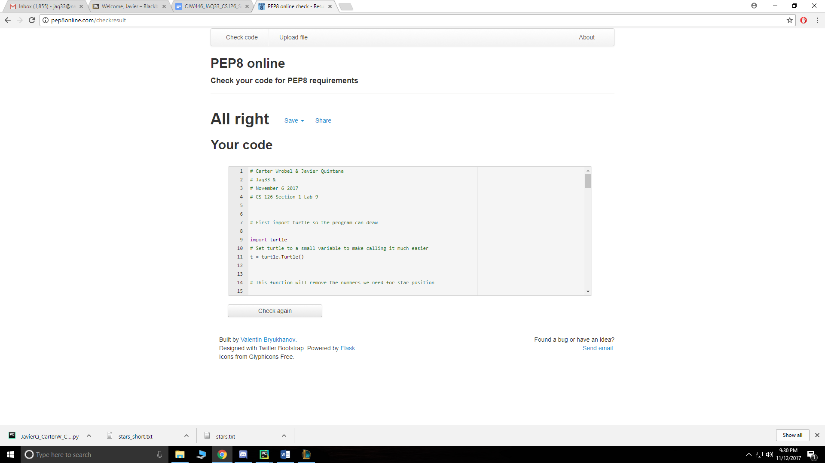

4. Reflection and Refactoring

When working on this lab, we didn’t have much of an issue getting the program running all the way until we made it to the plot_by_magnitude function. The plain stars would plot just fine because it only require the X and Y coordinates but when we moved onto magnitude the number controlling the dimensions of the stars was difficult due to how we had our scopes. When we figured out how to get the length and width we needed for each star it became instantaneously better for the program and it ran with virtually no issues. After evaluation of the stars we saw that one star was way bigger than it should have been. To fix the size of this star we set a conditional below the magnitude definition in the loop to make it so that if the length and width was greater than 8, we would restrict it to an 8 by 8 pixel star. After reworking numerous parts of the code, it was really interesting beginning work with the turtle module and learning how to use it to plot information and even draw basic shapes and interface. The lab was very enjoyable and at this point Pep8 compliance seems to have gotten significantly easier.